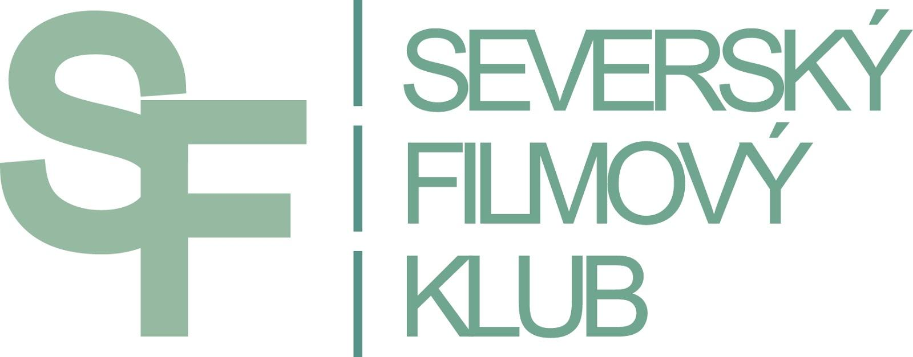

PRESS RELEASE

5. FIFTH ANNUAL AUTUMN FESTIVAL OF NORDIC FILMS
WILL BRING A BIT OF EVERY GENRE

PRAGUE, KINO LUCERNA, 1. – 5. 10. 2014
BRNO, KINO ART, 1. – 5. 10. 2014
HOSTIVICE, SOKOLOVNA, 17. – 18. 10. 2014
CHOCEŇ, KINO MÁJ, 2. – 5. 10. 2014
CHRASTAVA, KINO CHRASTAVA, 13. – 17. 10. 2014
JESENÍK, ENNEA CAFFÉ a KINO POHODA, 2. – 22. 10. 2014
JIČÍN, BIOGRAF ČESKÝ RÁJ, 1. – 29. 10. 2014
LITOMĚŘICE, KINO MÁJ, 15. – 31. 10. 2014
OSTRAVA, MINIKINO, 6. – 12. 10. 2014
PILSEN, MĚŠŤANSKÁ BESEDA, 8. – 30. 10. 2014
ÚSTÍ NAD LABEM, EXPERIMENTÁLNÍ PROSTOR MUMIE, 27. – 31. 10. 2014
TEPLICE, DŮM KULTURY TEPLICE, 13. – 14. 10. 2014
VESELÍ NAD MORAVOU, KINO MORAVA, 11. – 12. 10. 2014
ZLÍN, GOLDEN APPLE CINEMA, 2. – 5. 10. 2014

The Northern Lights will be flashing again from the screens of Prague's Lucerna Cinema and thirteen other Czech and Moravian cinemas. The autumn festival of Nordic cinematography will wander across the Czech Republic for the fifth time already, bringing a varied program of all genres. The viewers can look forward to ironic comedies and raw Nordic dramas. But even the fans of thrillers, sci-fi, Scandinavian nature and good music won't come up short. Even romance found a place in this year's program.
“We definitely don't aim to plunge the viewers into depression. Not everybody is the type for heavy Nordic dramas. For those we have prepared several comedies and two utterly romantic films,” says Lenka Bazinková, the director of the festival.

The program contains altogether 19 films from 5 Nordic countries, including 7 Swedish, 5 Danish, 2 Norwegian, 3 Finnish and 2 Icelandic. New films as well as older and lesser known films will be screened. Upon request of the spectators themselves, some popular films from previous festivals will be added to the program too – for these encore screenings, the newly opened small projection room of Lucerna with a capacity of 51 seats will be used.

The festival opens on the 1st of October with the Swedish sci-fi film LFO (2013), which is often mentioned in the context of the new wave of indie sci-fi films and compared with such films as Primer (USA, 2004) and Berberian Sound Studio (GB, 2012). It is a story about an insane radio amateur who discovers a unique frequency, which allows him to control other people's minds. Of course, he takes an advantage of his invention for incredible and often quite twisted acts. The authors of LFO – Antonio Tublén (director) and Alexander Brøndsted (producer) accepted the invitation and will be present at the opening.

The Danish drama EXPERIMENT deals with a social experiment which in the 50s aimed to re-educate children of Greenlandic Inuits and turn them into small Danes. They were supposed to become a model for future Greenlandic society. The film was one of six features in 2009 supported with government grant for its importance to the Greenlandic culture. And thanks to this film and the efforts of Ellen Hillingsø, who played the the female lead of the governess, Greenland finally received ​​an official apology for the harm caused to children and families who had gone through the experiment.

Also worth mentioning is also the Norwegian dramatic story IT'S ONLY MAKE BELIEVE, which won the Norwegian national award Amanda for Best Cinematography. It is a story of a woman who's trying to integrate into society after 10 years in jail and create a peaceful home for herself and her daughter. In this vision particularly, she puts all her hopes. Unfortunately, her efforts are disrupted by her unfortunate past, which returns like a boomerang.
This drama is based on a work of Arild Østin Ommundsen, who not only directed the film but is also it's screenwriter, producer, cinematographer and editor. For the major roles, he cast his own wife and daughter. His sister also appears in the film.

A breathtaking experience especially for fans of the Finnish symphonic metal band Nightwish, but also for fans of fantasy genre offers a film of Finnish-Canadian co-production IMAGINAERUM.

Among the promised romantic features is THE ONE AND ONLY (FI) and LOVE AND LEMONS (SE). And not only the female audience will be pleased by the fun Swedish comedy RALLYCHICKS.

As always, the festival tries to meet the needs of the audience with hearing impairments. All the films are provided with extended and colour modified subtitles. Each significant character has his or her own colour of subtitle. Information about noises and all other important events taking place outside the camera shot. The non-hearing impaired audience has welcomed the coloured subtitles as well because they facilitate orientation in complicated dialogues. The organisers haven't forgotten about foreigners either - when screening in Prague, Brno and Ostrava, films will be provided with English subtitles as well.

The festival is held by the Nordic Film Club with support of the City of Prague, Ministery of Culture and Nordic embassies.

More information about the festival and single movies can be found on Nordic Film Club’s website: www.sfklub.cz

CONTACT: Jana Stránská, tel. +420 776 356 730, pr@sfklub.cz

