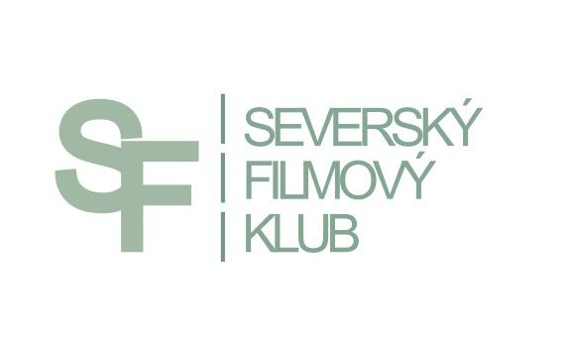

PRESS RELEASE

THE 4TH ANNUAL WINTER FESTIVAL OF NORDIC FILMS RETURNS TO PRAGUE AND CZECH REGIONS

PRAGUE, KINO LUCERNA, 27. 2. – 2. 3. 2014
BRNO, SLÉVÁRNA VAŇKOVKA, 26. 2. – 1. 3. 2014
HAVÍŘOV, KINO CENTRUM, 27. 2. – 2. 3. 2014
JESENÍK, ENNEA CAFFÉ a KINO POHODA, 27. 2. – 19. 3. 2014
JIČÍN, BIOGRAF ČESKÝ RÁJ, 4. 3. – 25. 3. 2014
OSTRAVA, MINIKINO, 3. 3. – 7. 3. 2014
ÚSTÍ NAD LABEM, EXPERIMENTÁLNÍ PROSTOR MUMIE, 24. – 28. 2. 2014
TEPLICE, DŮM KULTURY TEPLICE, 11. 3. – 12. 3. 2014
VESELÍ NAD MORAVOU, KINO MORAVA, 27. 2. – 2. 3. 2014
ZLÍN, GOLDEN APPLE CINEMA, 27. 2. – 2. 3. 2014
ŽELEZNÝ BROD, KC KINO BROD, 15 – 16. 3. 2014

A real nordic winter can be experienced in Prague’s Lucerna Cinema and other regional cinemas at the end of February. For four years already, the festival “Nordic Films' Winter” has been providing Czech spectators with a regular ration of rough nordic humor and raw, unembellished life stories set in the background of the beautiful Scandinavian countryside. Nearly 4,400 people attended last year's festival, showing a strong Czech interest in Nordic cinematography.

The organizers aim to present equally all countries and genders. Therefore, viewers can look forward to a multifarious show of films. New films as well as older lessor known films will be screened. On request of the spectators themselves, some popular films from previous festivals will be added to the program too. Altogether, 11 films will be screened in 4 days, including 2 Danish, 4 Norwegian, 1 Swedish, 1 Finnish and 3 Icelandic.

A high light of the festival is the Norwegian feature THE KAUTOKEINO REBELLION. This impressive drama gives insight into the life of the indigenous Sámi people of Northern Norway. Set in the historical background of a real event from 1852, when this usually nonviolent ethnic group rose up against the Norwegian rule. The Norwegian director of Sámi origin, Nils Gaup, comes from the town of Kautokeino and is a descendant of one of the executed rebels. , The Sami people also inspired him in his debut film, Pathfinder, which was nominated for an Academy Award for Best Foreign Language Film in 1988. This film, full of beautiful natural scenery and great music, won 4 Amanda National Film Awards. The female lead is played by Anni-Kristiina Juuso, well known by Czechs from her work in The Cuckoo feature. Popular Swedish actor Michael Nyqvist, from movies As It Is in Heaven or The Girl with the Dragon Tattoo, also has a minor part in the movie.

The Icelandic drama, THE SEAGULL'S LAUGHTER is set in the early fifties. A young widow Freya (Margrét Vilhjálmsdóttir) returns home from the United States. Her arrival turns the quiet fishing village near Reykjavik city upside down. The whole story is narrated by Freya's eleven year old cousin Agga. Ugla Egilsdóttir has been awarded best female actor at 2002 Karlovy Vary MFF for the role of Agga.

Danish cinematography is represented by HUSH LITTLE BABY, a film by the Danish-Gambian director Helly Joof. It is a road-movie about four girls escaping from a drug rehabilitation centre. In a stolen Volvo, they set out to settle their score with life. Malou Reman was nominated for the Robert National Film Award for her role as one of the girls.

The program contains also two new movies – Icelandic spooky comedy SPOOKS AND SPIRITS and Norwegian romantic comedy KISS ME, YOU FUCKING MORON.

As every year, the festival tries to meet the needs of the audience with hearing impairments. All the films are provided with extended and colour modified subtitles. Each significant character has his or her own colour of subtitle. Information about noises and all other important events taking place outside the camera shot or otherwise inaccessible to the spectator with hearing impairment is provided. The non-hearing impaired audience has welcomed the coloured subtitles as well because they facilitate orientation in complicated dialogues. The organisers ;haven't forgotten about foreigners either - when screening in Prague, Brno and Ostrava, all films will be provided with English subtitles as well.

The festival is held by the Nordic Film Club with the support of the city of Prague, the Nordic embassies and, last but not least, of the fans of Nordic films themselves. Last year, they contributed over 80 thousand Czech Crowns via public collection on the hithit.cz website.
“We’re a bunch of people with common interest in Nordic movies. We aim to deliver them to the Czech audience because we believe the Nordic cinematography is unique in it’s way, but unfortunately, compared to the cinematography of other countries, still a bit less represented,” says Lenka Bazinková, the director of the festival.

More information about the festival and single movies can be found on Nordic Film Club’s website: www.sfklub.cz

CONTACT: Jana Stránská, tel. +420 776 356 730, pr@sfklub.cz

