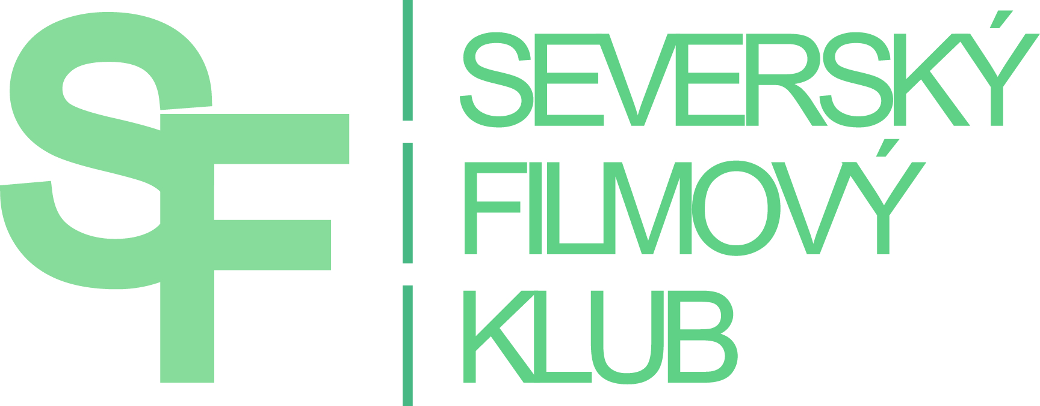
PRESS RELEASE 14. 1. 2017

7th NORDIC FILM WINTER FESTIVAL
OPENS BY DIRECTOR JAN VARDØEN

Biting cold will hit 13 Czech and Moravian cinemas. Nordic Film Club brings the traditional exhibition of Nordic movies for the seventh time – fittingly named Nordic Film Winter. Typical Nordic humor, raw dramas and atmospheric crime stories set in stunning Scandinavian nature. Festival will premiere 11 new films from the Nordic production and several successful films at the request of the audience. Seventh festival offers 26 films from 7 countries – 8 Norwegian,
8 Swedish, 4 Finnish, 2 Danish, 2 Icelandic, 1 Lithuanian and 1 Estonian.

The opening ceremony of the Nordic Film Winter festival will open with the presence of winsome Nordic director, writer, musician and restaurant owner Jan Vardøen. Three of his films will be shown at the festival. House of Norway is an exclusive European preview. The film reflects on current migration crisis from humorous perspective, and points out how we can be perceived by people from different cultures. Comedy drama Høst: Autumn Fall follows a turbulent relationship of National theatre stage manager with a successful actor and explores the theme of love in all its forms. Heart of Lightness references the stage play The Lady from the Sea by Henrik Ibsen, not omitting funny stories from making the movie. The main part of the director portrayed Jan Vardøen himself.

New film by Natasha Arthy arrives from Denmark. Comeback is a comedy about second chances. Finnish drama film Off the Map, follows a woman who finds out that her husband lives a double life. She finds a big amount of money and decides to leave everything behind. Finnish-Lithuanian film 2 Nights Till Morning tells a story about Finnish DJ and a French architect who spend two nights together in Lithuanian town Vilnius because of volcanic ash cloud. Abundance of Nordic humor ensures Swedish comedy Greetings from North. Story about Nadja, who has a week to find a partner and get married due to changes in adoption laws. Worth mentioning are films by talented Swedish director Andreas Öhman. Bittersweet comedy Simple Simon brings to audiences a life story about a boy with Asperger’s syndrome. In 2011 was the film nominated for Guldbaggen price for best film, screenplay, actor and actress in supporting role. Romantic adventures turn into dangerous game in a drama film Eternal Summer, staring stunning Madeleine Martin and Filip Berg.

As a tradition, we bring several movies that were created with a cooperation of favorite Nordic book authors. Book by Ingvar Ambjørnsen, known to Czech readers as trilogy about Elling, inspired creators to make a nerve wracking thriller Revenge. Film about carefully plotted revenge for unforgettable injustice shows how behavior of the main character affects everybody around her and not just the object of her revenge. Gunnhild Øyehaug, awarded Nynorsk litteraturpris book author, also nominated for Nordic film award for best screenplay, brings Women in Oversized Men's Shirts, a dramedy about three different women searching for identity and happiness. Finnish drama Love and Fury maps turbulent love story between two writers. When they met, he was successful and she was waiting for her big break. Later the sides turn. Film is based on a successful novel by Anji Snellman and the author admits autobiographic motives.

Documentary Nice People describes the story of the first bandy team in Somalia. Young players, who never stood on ice skates, upcoming World championship and the team coaches, who see everything differently. The documentary captures the time before and during the championship.

Secret favorite of the festival organisers is Estonian war drama 1944. In 1939 the Soviet Union makes a Ribbentrop – Molotv pact with Germany and the Second World War starts week later. In 1940 Soviet Union occupies Estonia and 55 000 people are forced to enter the Red Army. One year later is Estonia occupied by Germany and 72 000 Estonians are conscripted into the German forces. In September 1944 the Red Army returns to Estonian borders and the remaining Estonian forces fight the Soviets till the 50ties; period of murders, political cases, terror and most importantly deportation to the Soviet labor camps in Siberia.

Dramedy Stockholm stories returns at the request of the audience; story about five people who come together because of sudden power shortage. Alicia Vikander stars in a drama The Crown Jewels as a woman, who was accused of attempted murder. Norwegian teenage romantic comedy Kiss Me You Fucking Moron promises intelligent humor, atmosphere full of melancholy and the beauty of the Nordic nature.

The festival has long been trying to meet the demands of viewers with hearing disabilities. All films are provided with color-modified subtitles. Each important character of the movie has its own color of subtitles. For the deaf viewers, so they can easily follow the movie, there is also information about noises and all the storylines that are out of focus and are important for understanding the plot. According to the response of all spectators, the colorful subtitles are welcomed, because they help in orientation in more complex dialogs. Organizers do not forget about foreigners - when showing in Prague, Brno and Ostrava, the films will be also provided with English subtitles.
The festival is organized by the Nordic Film Club with the financial support of Volvo Car Czech Republic s.r.o., Ministry of Culture of Czech Republic, Brno City Hall and embassies of the Nordic countries.

PRAHA, KINO LUCERNA, 9. – 15. 2. 2017
BRNO, SÁL BŘETISLAVA BAKALY, 14. – 23. 2. 2017
HODONIN, KINO SVET, 14. 2. – 1. 3. 2017
HOSTIVICE, SOKOLOVNA, 3. – 4. 3. 2017
HRADEC KRALOVE, BIO CENTRAL, 8. – 10. 2. 2017
JABLONEC NAD NISOU, KINO JUNIOR, 9. 2. – 9. 3. 2017
JESENIK, ENNEA CAFFE, 9. 2. – 23. 2. 2017
LIBEREC, KINO VARSAVA, 16. – 18. 2. 2017
OSTRAVA, MINIKINO, 10. – 14. 2. 2017
TREBUSIN, KINO KALICH, 24. – 25. 2. 2017
USTI NAD ORLICI, MALA SCENA, 11. 2 – 12. 2. 2017
VESELI NAD MORAVOU, KINO MORAVA, 11. – 12. 3. 2017
ZLIN, GOLDEN APPLE CINEMA, 23. 2– 1. 3. 2017

More information about the festival and individual films can be found on the website of the Nordic Film Club: www.sfklub.cz

CONTACT: Tereza Lysa, tel. +420 602 456 762, pr@sfklub.cz

