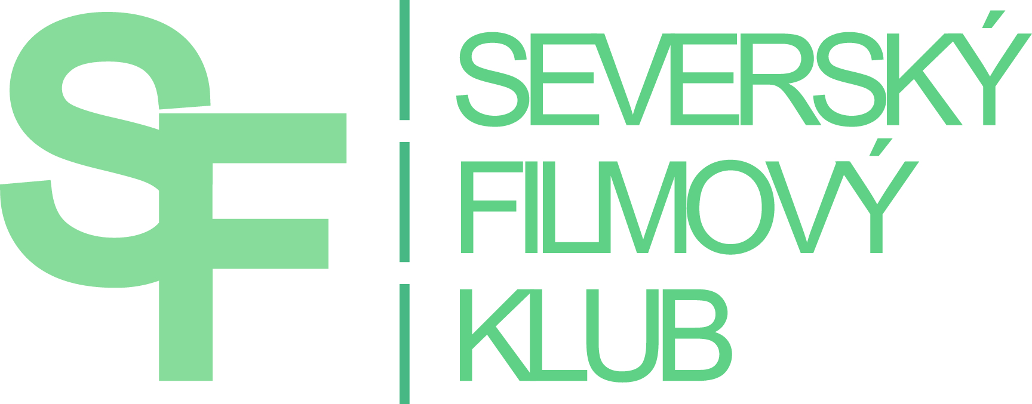
PRESS RELEASE

THE 6TH ANNUAL FESTIVAL OF NORDIC FILMS
SUPPORTS THE #READNORDIC LITERARY CAMPAIGN

Northern winds will hit the Czech cinemas again , bringing along the sixth edition of the Nordic Film Autumn, the festival full of crazy comedies and harsh Nordic dramas with no happy ending guaranteed.
The festival, organized by the Nordic Film Club, will wander across the country visiting 13 Czech and Moravian cities. All together 26 films from 5 Nordic countries will be shown – 12 Swedish, 2 Finnish, 6 Norwegian, 5 Danish and 1 Icelandic. New films as well as older and lesser known films will be screened. Upon request of the spectators themselves, some popular films from previous festivals will be added to the program too.

One of the new films shown at the festival is the Icelandic drama, Rams, which won the Un Certain Regard Award in Cannes. Czech viewers have so far only had the opportunity to see it at the festival in Karlovy Vary. Furthermore, there is a new film by the popular Danish-Gambian director Hella Joof, All inclusive, with Bodil Jørgensen in the lead role. And fans of Sci-fi will certainly enjoy the crazy Finnish Sci-fi comedy Lovemilla. This film will open the festival in Prague on October 26th. Sci-fi is experiencing a boom in Finland and Lovemilla literally caused mass hysteria among Finnish youths. Teemu Nieminen, one of the Lovemilla actors, has accepted our invitation and will be present at the opening.

This year's festival will support the literary campaign #ReadNordic, recently launched by the Nordic Embassies, with three films based on books. One of them is the Finnish-Swedish feature Raspberry Boat Refugee. A comic story about a man (Jonas Karlson) who has been, since his childhood, convinced that his Swedish soul has been trapped in a Finnish body. It won the Best Film Award at the Norwegian International Festival in Haugesund. The author of the novel is Miika Nousiainen. The second book based film is also a commedy, The Last Joint Venture by Norwegian writer Ingvar Ambjørnsen. A story about two minor marijuana dealers (Kristoffer Joner and Nicolai Cleve Broch), who in the late 70s decided to establish a free community similar to the Danish Christiania. To get enough money to build it, they plan their last but also the largest piece of smuggling. Ingvar Ambjørnsen is known for his tetralogy about Elling. The film adaptation of Elling was nominated for the Oscar for the Best Foreign Film in 2001.
The three-hour drama Never Wipe Tears Without Gloves is a very strong story about the gay community in Sweden in the 80s, when AIDS has just appeared - still at that time still an unknown disease. The author of the book trilogy is Jonas Gardell. The Nordic Film Club is preparing even more film adaptations of Nordic books for their winter film festival (March 2016). The campaign #ReadNordic will culminate in May at Prague's book fair Svět knihy 2016.

Also worth mentioning is an older, but surprisingly an actual Swedish drama, New Country (2000), about two illegal immigrants - Ali, a fifteen year old Somali boy, and Massoud, a forty year old Iranian, who ran away from a refugee camp and wandered through a seemingly carefree summer Sweden.

The Nordic Film Winter is the only festival in the Czech Republic fully adapted to viewers with hearing impairments. As usual, all the films are provided with extended and colour modified subtitles, with extra information about noises and all other important events taking place outside the camera shot. According to the response, the coloured subtitles are appreciated also by the hearing audience, as they help the orientation in more complex dialogs.
The organizers do not forget about foreigners either - all screenings in Prague, Brno and Ostrava will be provided with English subtitles as well.

The festival is held by the Nordic Film Club with support of the Nordic Culture Fund, Ministery of Culture, City of Prague and Nordic embassies.

PRAGUE, KINO LUCERNA, 26. 10. – 1. 11. 2015
BRNO, KINO ART, 22. – 27. 10. 2015
HOSTIVICE, SOKOLOVNA, 23. – 24. 10. 2015
HRANICE, DIVADLO STARÁ STŘELNICE, 22. 10. 2015
JABLONEC N. N., KINO JUNIOR, 29. 10. – 26. 11. 2015
JESENÍK, ENNEA CAFFÉ a KINO POHODA, 27. 10. – 26. 11. 2015
JIČÍN, BIOGRAF ČESKÝ RÁJ, 3. 11. – 1. 12. 2015
LITOMĚŘICE, KINO MÁJ, 2. – 30. 11. 2015
OSTRAVA, MINIKINO, 2. – 6. 11. 2015
ÚSTÍ NAD LABEM, KINO HRANIČÁŘ a FOKUS KAFE, 2. – 26. 11. 2015
TEPLICE, DŮM KULTURY TEPLICE a FOKUS KAFE, 19. – 26. 11. 2015
ZÁBŘEH, KINO RETRO, 28. 10. – 11. 11. 2015
ZLÍN, GOLDEN APPLE CINEMA, 22. – 25. 10. 2015

More information about the festival and single movies can be found on Nordic Film Club’s website: www.sfklub.cz

CONTACT: Jana Stránská, tel. +420 602 501 021, pr@sfklub.cz

